P R I N C I PA L S O F T WA R E D E V E L O P E R

LANDON MERCER

. N E T • S Q L S E R V E R • C LO U D - N AT I V E A R C H I T E C T U R E • A I - R E A D Y S Y S T E M S
15+ years building mission‑critical .NET and SQL Server platforms, leading engineering teams, and evolving legacy estates into cloud-native, AI-augmented solutions.

LO C AT I O N
Remote / Hybrid – Open to US & EU
P H O N E
+1 (555) 123‑4567
E M A I L
landon.mercer.dev@example.com
L I N K E D I N / G I T H U B
linkedin.com/in/landonmercer · github.com/landonmercer

P R O F I L E S U M M A R Y
Principal-level engineer and hands-on architect specializing in high-throughput .NET and SQL Server platforms. Expert in designing and refactoring distributed systems, optimizing database performance, and coaching teams toward clean, testable, cloud-ready code. Recently focused on introducing AI capabilities using Semantic Kernel and Azure OpenAI to augment existing .NET services with retrieval-augmented generation, semantic search, and intelligent orchestration.
. N E T 6 / 7 / 8 C # A S P . N E T CO R E S Q L S E R V E R A Z U R E E V E N T - D R I V E N

S E M A N T I C K E R N E L L E A D E R S H I P

C O R E E N G I N E E R I N G S K I L L S . N E T & S Q L S E R V E R

C# / .NET (Framework, Core, .NET 8)
API DESIGN · ASYNC · DIAGNOSTICS

9.5 / 10

ASP.NET Core Web API
REST · MINIMAL APIS · FILTERS

9 / 10

Extensive back-end services, microservices, background workers, libraries.
High-performance APIs with versioning, middleware pipelines, and observability.

SQL Server & T‑SQL
SCHEMA · INDEXING · TUNING

9.6 / 10

EF Core / Dapper
ORM STRATEGY · TRANSACTIONS

8.8 / 10

Query optimization, execution plans, partitioning, troubleshooting deadlocks.
Balanced patterns: raw T‑SQL, Dapper, and EF Core where each fits best.


Architecture & Design
DDD · CQRS · MESSAGING

Performance & Scalability
PROFILING · CACHING · LOAD

9.2 / 10
Domain modeling, bounded contexts, event-driven and modular monolith designs.

Profiling (dotTrace, PerfView), caching strategies, connection pooling, batching.
9 / 10

E X P E R I E N C E S E L E C T E D R O L E S

Principal Software Developer FinEdge Systems · Remote 2020 – Present

Lead Software Engineer NorthBridge Health 2014 – 2020

Senior Software Engineer BrightPath Logistics 2010 – 2014
Principal .NET & SQL Architect – Trading & Risk Platform Led modernization of a legacy .NET / SQL Server monolith into a modular API layer and event-driven services, cutting deployment
lead time by 70%.
Redesigned critical T‑SQL procedures and indexes for trade matching; reduced average latency from 1.2s to under 200ms at peak load.
Introduced observability stack (structured logging, metrics, tracing) across .NET services and database to support SLOs and on-call rotations.
Mentored a team of 10+ engineers, establishing coding standards, review practices, and design documentation guidelines.

Lead .NET Engineer – Care Management Suite
Owned architecture for patient management and billing subsystems built on ASP.NET, WCF (legacy), and SQL Server.
Implemented multi-tenancy, row-level security, and encryption at rest/in transit to support HIPAA compliance.
Designed ETL processes (SSIS + C# loaders) to consolidate data from 10+ hospital systems into a single reporting database.
Introduced automated regression testing and CI/CD pipelines, significantly reducing production defects per release.
Senior .NET / SQL Developer – Routing & Tracking Developed core routing algorithms and scheduling services in C# with heavy SQL Server integration.
Optimized geospatial queries (SQL Server) and caching layer, cutting routing run times by more than 60%.
Collaborated with operations teams to translate complex logistics workflows into robust, testable code.

A I & S E M A N T I C K E R N E L E M E R G I N G S K I L L S
I N T R O D U C TO R Y P R A C T I T I O N E R Recently focused on introducing AI features safely into
established .NET platforms:

Semantic Kernel for .NET
PLUGINS · PL ANNERS · CONNECTORS

5 / 10
Built a proof-of-concept “developer assistant” plugin over internal APIs using Semantic Kernel planners.
Experimented with RAG-style document answering via

Hands-on prototypes integrating Semantic Kernel into existing ASP.NET Core services: prompt
Azure Cognitive Search and embeddings.

templates, function orchestration, and basic vector search scenarios.
Defined patterns for prompt versioning, telemetry, and guardrails within existing CI/CD workflows.
Comfortable guiding teams from zero to first working AI-backed feature, with a focus on reliability, observability,

P L A T F O R M & L E A D E R S H I P S U P P O R T I N G S K I L L S

Azure Cloud
APP SERVICE · AKS · SQL DB

8.2 / 10

DevOps & CI/CD
GITHUB ACTIONS · A ZURE DEVOPS

8 / 10

Deploying and operating .NET APIs, Azure SQL, Key Vault, Storage, Service Bus.
Build/test pipelines, release gating, blue‑green deployments, DB migration strategies.

Testing Strategy
UNIT · INTEGRATION · CONTRACT

8.4 / 10

Technical Leadership
MENTORING · ROADMAPS

8.9 / 10

xUnit, NUnit, test harnesses for .NET + SQL interactions, mocks vs. fakes guidance.
Leading guilds, running design reviews, shaping architecture direction with stakeholders.

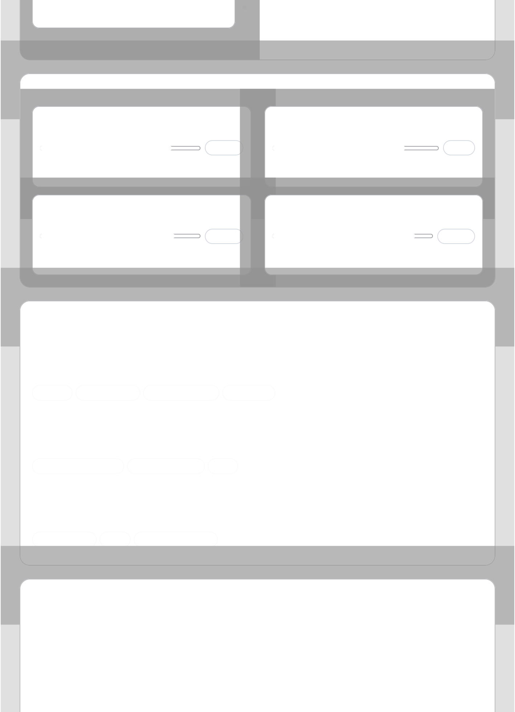

K E Y W O R K S E L E C T E D P R O J E C T S

High-Throughput Trading API Platform (.NET & SQL Server)
Principal Developer · FinEdge Systems
Re-architected trade ingestion and risk calculation services into a horizontally-scalable ASP.NET Core and SQL Server solution handling millions of daily transactions.
. N E T 7 S Q L S E R V E R E V E N T - D R I V E N C AC H I N G

AI-Assisted Developer Companion (Semantic Kernel POC)
Internal R&D · FinEdge Systems
Created a prototype developer assistant using Semantic Kernel and Azure OpenAI to answer questions about internal APIs, generate sample integration code, and propose test cases.
S E M A N T I C K E R N E L A Z U R E O P E N A I R AG

Unified Healthcare Reporting Warehouse
Lead Engineer · NorthBridge Health
Designed and implemented an enterprise reporting database and ETL pipeline consolidating 10+ EHR/PM systems, enabling self-service analytics and regulatory reporting.
S Q L S E R V E R S S I S DATA M O D E L I N G

E D U C A T I O N & C E R T I F I C A T I O N S B A C K G R O U N D

B.Sc. in Computer Science
State University of Technology
Focus on software engineering, algorithms, and database systems.

Microsoft Certified: Azure Developer Associate
Microsoft
Building, testing, and maintaining cloud applications and services on Azure.
Internal & Community Learning

Ongoing learning via Microsoft docs, community talks, and prototypes focused on Semantic Kernel, Azure OpenAI, and responsible AI practices in .NET ecosystems.
References and detailed project portfolio available on request.

